No Segment Intersection

Definition
# Source: AI Source: Provided by: [Data Path: Persons Table -> ID Column: 1, Name_En Column: Motasem Essam] -> From: [ChatGPT] on [7/25/2026]
No Segment Intersection occurs when two line segments have no common point.
If segments $\overline{AB}$ and $\overline{CD}$ do not share any point, their intersection is the empty set:
$$\boxed{\overline{AB}∩\overline{CD}=∅}$$
This means that the two segments are completely separate.
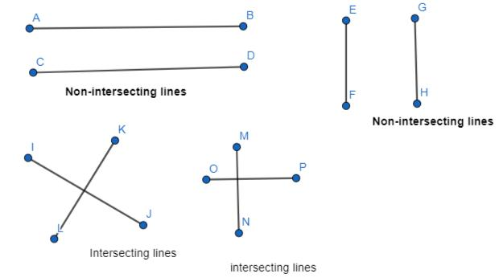
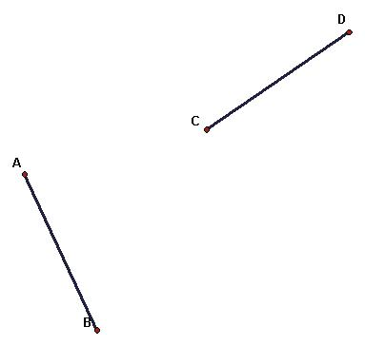
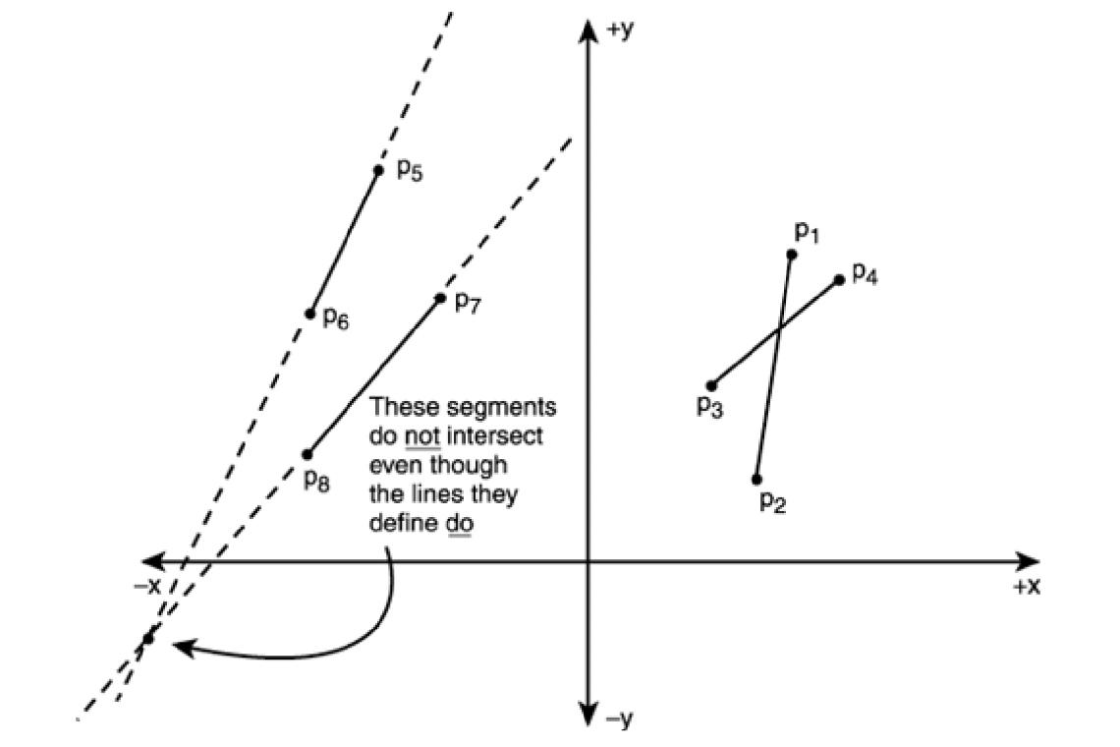

Purpose
# Source: AI Source: Provided by: [Data Path: Persons Table -> ID Column: 1, Name_En Column: Motasem Essam] -> From: [ChatGPT] on [7/25/2026]
No Segment Intersection is used to:
- Determine whether two segments are completely separate.
- Analyze geometric relationships.
- Identify disconnected parts of a figure.
- Check whether paths cross.
- Detect collisions or non-collisions.
- Analyze polygon edges.
- Support CAD and GIS operations.
- Perform computational geometry calculations.

Fundamental Idea
# Source: AI Source: Provided by: [Data Path: Persons Table -> ID Column: 1, Name_En Column: Motasem Essam] -> From: [ChatGPT] on [7/25/2026]
Two line segments have no segment intersection when there is no point that belongs to both segments.
For example:
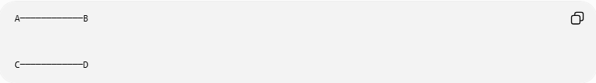
A────────────B

C────────────D
The segments are separate.
Therefore:
$$\boxed{\overline{AB}∩\overline{CD}=∅}$$
There is no point $P$ such that:
$$P∈\overline{AB}$$
and:
$$P∈\overline{CD}$$
at the same time.

Mathematical Representation
# Source: AI Source: Provided by: [Data Path: Persons Table -> ID Column: 1, Name_En Column: Motasem Essam] -> From: [ChatGPT] on [7/25/2026]
The standard mathematical notation is:
$$\boxed{\overline{AB}∩\overline{CD}=∅}$$
The symbol:
$$\boxed{∅}$$
means empty set.
Therefore:
$$\boxed{\text{No common points}}$$

Simple Example
# Source: AI Source: Provided by: [Data Path: Persons Table -> ID Column: 1, Name_En Column: Motasem Essam] -> From: [ChatGPT] on [7/25/2026]
Consider:
$$A=\left(0,0\right) \\ B=\left(4,0\right)$$
and:
$$C=\left(0,3\right) \\ D=\left(4,3\right)$$
The first segment lies on:
$$y=0$$
while the second lies on:
$$y=3$$
Therefore, they never meet.
$$\boxed{\overline{AB}∩\overline{CD}=∅}$$
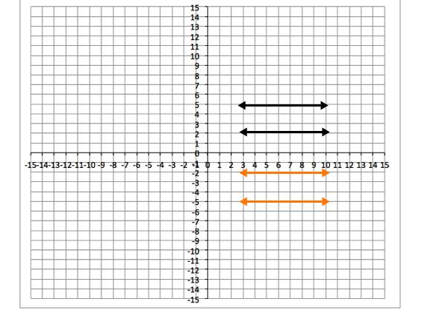
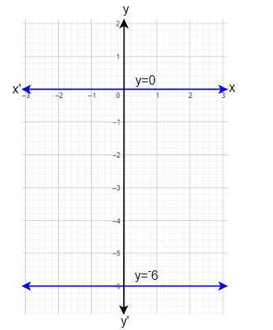
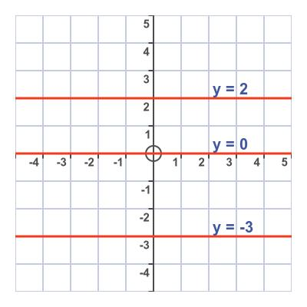

Types of No Segment Intersection
No intersection can occur in several different geometric arrangements.

1. Separate Segments
# Source: AI Source: Provided by: [Data Path: Persons Table -> ID Column: 1, Name_En Column: Motasem Essam] -> From: [ChatGPT] on [7/25/2026]
The segments are completely separated.
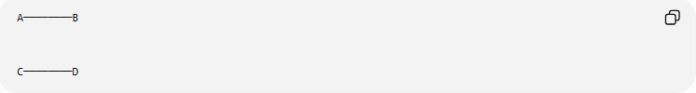
A────────B

C────────D
There is a visible gap between them.
$$\boxed{\overline{AB}∩\overline{CD}=∅}$$

2. Parallel Non-Intersecting Segments
# Source: AI Source: Provided by: [Data Path: Persons Table -> ID Column: 1, Name_En Column: Motasem Essam] -> From: [ChatGPT] on [7/25/2026]
Two segments can be parallel but located on different lines.
For example:
$$\overline{AB}∥\overline{CD}$$
and:
$$\overline{AB}∩\overline{CD}=∅$$
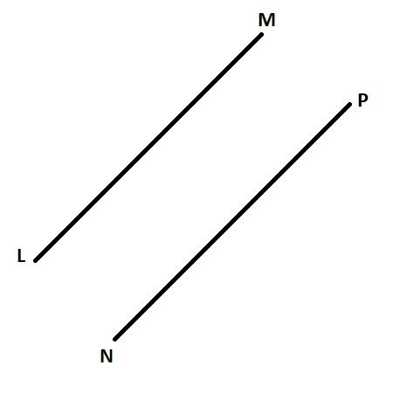
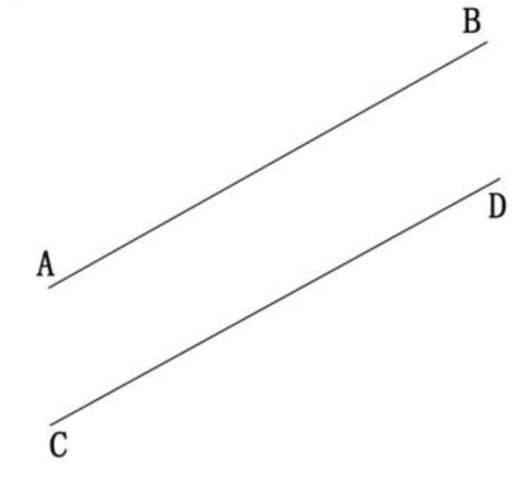
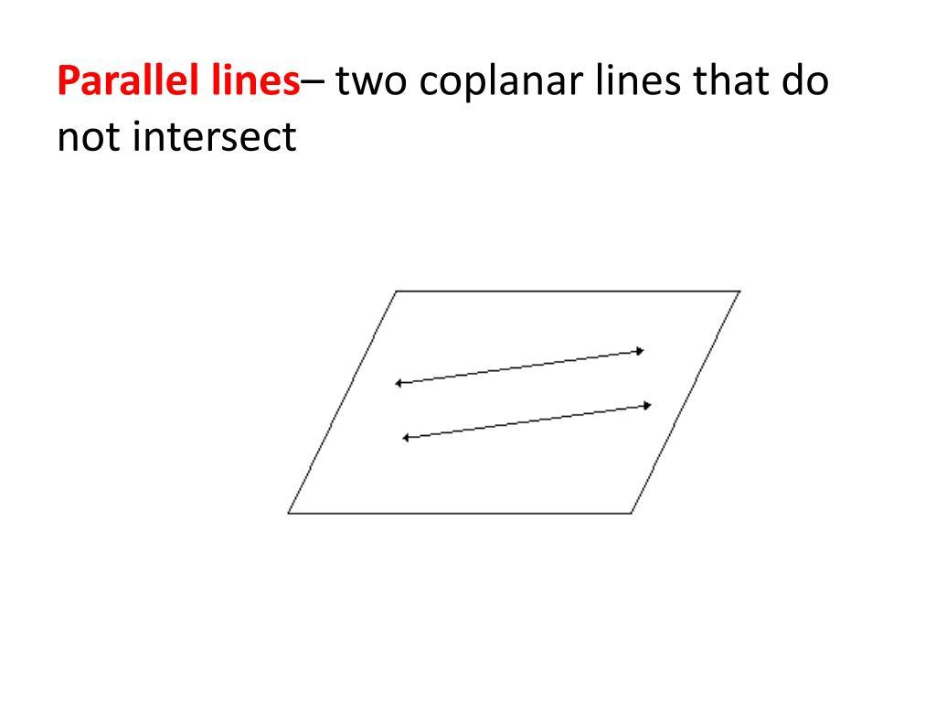

3. Non-Collinear Segments That Miss Each Other
# Source: AI Source: Provided by: [Data Path: Persons Table -> ID Column: 1, Name_En Column: Motasem Essam] -> From: [ChatGPT] on [7/25/2026]
Two segments can have different directions but still fail to meet.
For example:
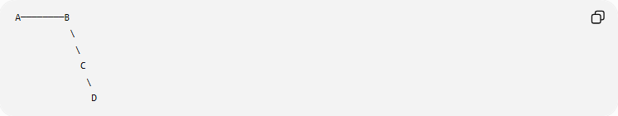
A────────B
\
\
C
\
D
Depending on their endpoints and directions, the segments may remain completely separate.
Their supporting lines might intersect somewhere, but the finite segments themselves do not.
This is an important distinction.
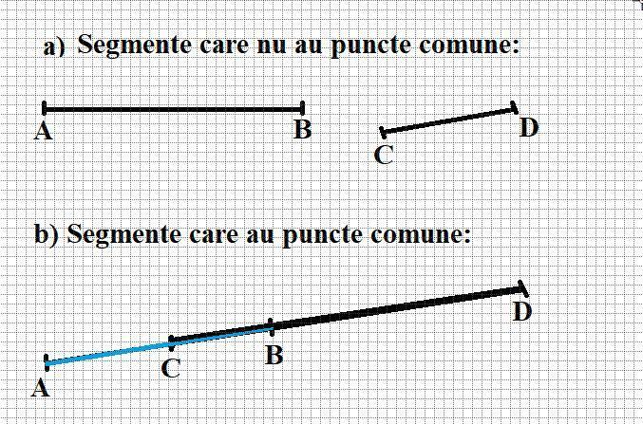
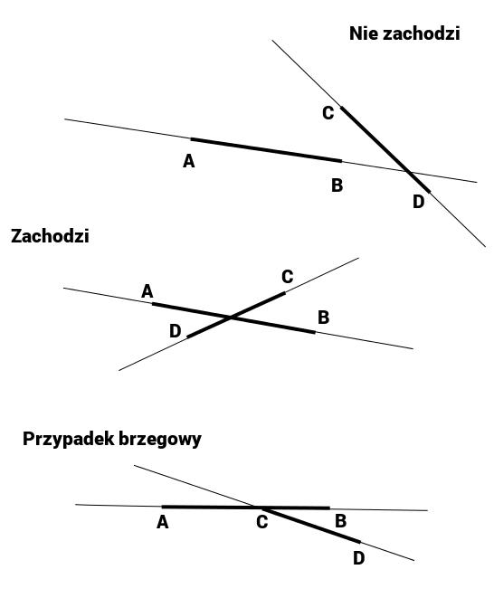

Supporting Lines vs. Line Segments
# Source: AI Source: Provided by: [Data Path: Persons Table -> ID Column: 1, Name_En Column: Motasem Essam] -> From: [ChatGPT] on [7/25/2026]
This is one of the most important concepts.
Two infinite lines may intersect while their finite segments do not.
For example:
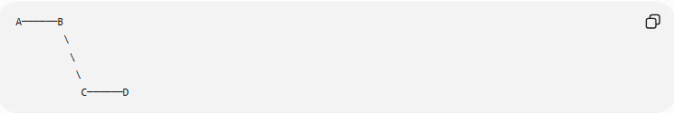
A──────B
\
\
\
C──────D
The infinite lines containing these segments may meet beyond the endpoints.
However:
$$\boxed{\overline{AB}∩\overline{CD}=∅}$$
because the intersection point is not part of either finite segment.

No Segment Intersection vs. Endpoint Intersection
# Source: AI Source: Provided by: [Data Path: Persons Table -> ID Column: 1, Name_En Column: Motasem Essam] -> From: [ChatGPT] on [7/25/2026]
Endpoint Intersection
Two segments share an endpoint:
$$\boxed{\overline{AB}∩\overline{BC}=B}$$
No Segment Intersection
Two segments share no points:
$$\boxed{\overline{AB}∩\overline{CD}=∅}$$
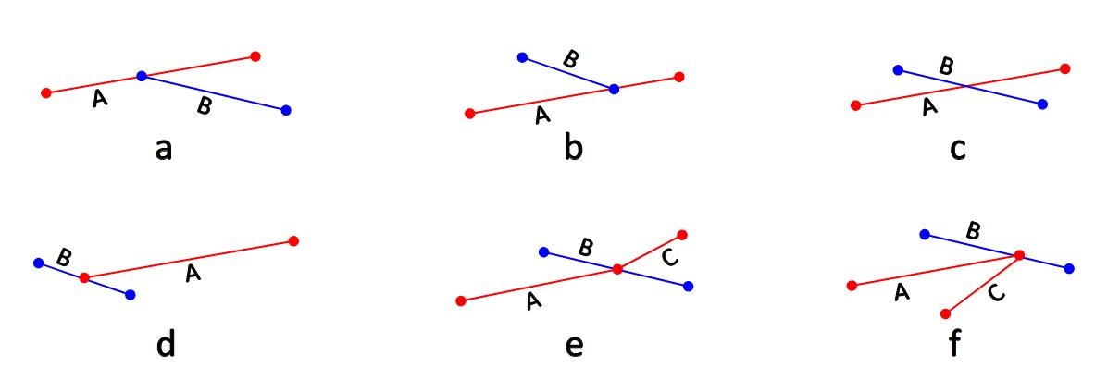

No Segment Intersection vs. Interior Intersection
# Source: AI Source: Provided by: [Data Path: Persons Table -> ID Column: 1, Name_En Column: Motasem Essam] -> From: [ChatGPT] on [7/25/2026]
Interior Intersection
The segments cross inside both segments:
$$\boxed{\overline{AB}∩\overline{CD}=\{P\}}$$
where $P$ is an interior point.
No Segment Intersection
The segments never meet:
$$\boxed{\overline{AB}∩\overline{CD}=∅}$$
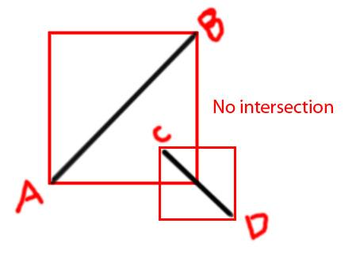

No Segment Intersection vs. Overlapping Intersection
# Source: AI Source: Provided by: [Data Path: Persons Table -> ID Column: 1, Name_En Column: Motasem Essam] -> From: [ChatGPT] on [7/25/2026]
Overlapping
Two collinear segments share a portion:
$$\boxed{\overline{AB}∩\overline{CD}=\overline{PQ}}$$
No Intersection
They have no common point:
$$\boxed{\overline{AB}∩\overline{CD}=∅}$$
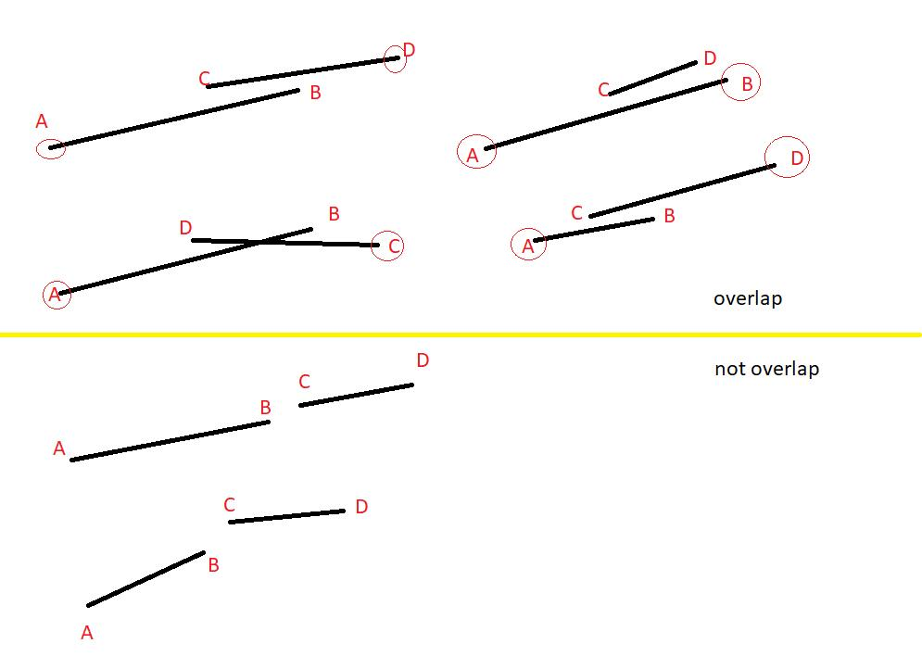

Coordinate Geometry
# Source: AI Source: Provided by: [Data Path: Persons Table -> ID Column: 1, Name_En Column: Motasem Essam] -> From: [ChatGPT] on [7/25/2026]
Suppose:
$$A=\left(1,1\right) \\ B=\left(4,1\right)$$
and:
$$C=\left(1,4\right) \\ D=\left(4,4\right)$$
The first segment lies on:
$$y=1$$
and the second lies on:
$$y=4$$
Therefore:
$$\boxed{\overline{AB}∩\overline{CD}=∅}$$

Distance Between Non-Intersecting Segments
# Source: AI Source: Provided by: [Data Path: Persons Table -> ID Column: 1, Name_En Column: Motasem Essam] -> From: [ChatGPT] on [7/25/2026]
When two segments do not intersect, the distance between them can sometimes be calculated.
For parallel horizontal segments:
$$y_{1}=1$$
and:
$$y_{2}=4$$
the perpendicular distance is:
$$d=\left|y_{2}-y_{1}\right|$$
Therefore:
$$\boxed{d=\left|4-1\right|=3}$$
The positive distance confirms that the segments are separated.

No Intersection in a Number Line
# Source: AI Source: Provided by: [Data Path: Persons Table -> ID Column: 1, Name_En Column: Motasem Essam] -> From: [ChatGPT] on [7/25/2026]
Consider:
$$\left[1,4\right]$$
and:
$$\left[7,10\right]$$
There is no common value.
Therefore:
$$\boxed{\left[1,4\right]∩\left[7,10\right]=∅}$$
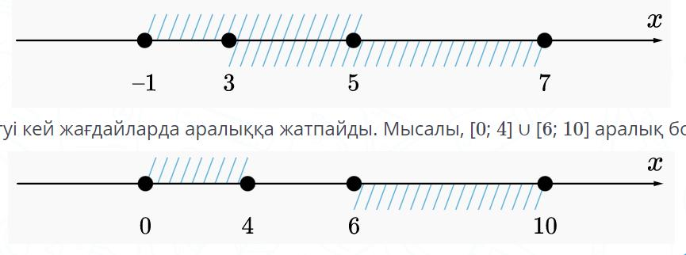
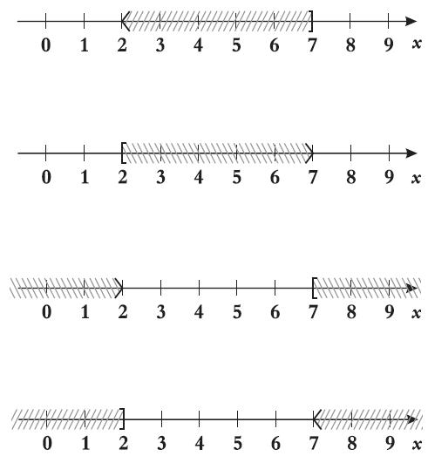
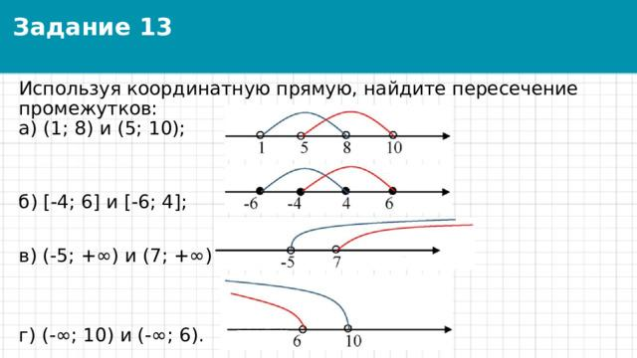

Mathematical Condition for Disjoint Intervals
# Source: AI Source: Provided by: [Data Path: Persons Table -> ID Column: 1, Name_En Column: Motasem Essam] -> From: [ChatGPT] on [7/25/2026]
For two intervals:
$$\left[a,b\right]$$
and:
$$\left[c,d\right]$$
they have no intersection when:
$$\boxed{b<c}$$
or:
$$\boxed{d<a}$$
For example:
$$\left[1,4\right]$$
and:
$$\left[7,10\right]$$
satisfy:
$$4<7$$
Therefore:
$$\boxed{\left[1,4\right]∩\left[7,10\right]=∅}$$

Collinear Segments With No Intersection
# Source: AI Source: Provided by: [Data Path: Persons Table -> ID Column: 1, Name_En Column: Motasem Essam] -> From: [ChatGPT] on [7/25/2026]
Two segments can be on the same straight line but still have no intersection.
For example:
A──────B C──────D
They are collinear, but there is a gap between $B$ and $C$.
Therefore:
$$\boxed{\overline{AB}∩\overline{CD}=∅}$$

Non-Collinear Segments With No Intersection
# Source: AI Source: Provided by: [Data Path: Persons Table -> ID Column: 1, Name_En Column: Motasem Essam] -> From: [ChatGPT] on [7/25/2026]
Segments do not have to be parallel to be non-intersecting.
For example:
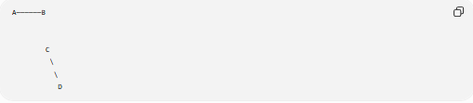
A──────B

C
\
\
D
The segments can have different directions and still remain separate.
The important condition is:
$$\boxed{\text{No common point}}$$

Intersection of Supporting Lines
# Source: AI Source: Provided by: [Data Path: Persons Table -> ID Column: 1, Name_En Column: Motasem Essam] -> From: [ChatGPT] on [7/25/2026]
Suppose the infinite lines containing two segments intersect at $P$.
If:
$$P∉\overline{AB}$$
or:
$$P∉\overline{CD}$$
then $P$ is not a segment intersection.
Therefore:
$$\boxed{\overline{AB}∩\overline{CD}=∅}$$
This distinction is particularly important in coordinate geometry and computational geometry.

No Intersection in Polygons
# Source: AI Source: Provided by: [Data Path: Persons Table -> ID Column: 1, Name_En Column: Motasem Essam] -> From: [ChatGPT] on [7/25/2026]
Two non-adjacent polygon edges may sometimes have no intersection.
For example, in a convex polygon, two separated edges do not cross:
$$\boxed{E_{1}∩E_{2}=∅}$$
This helps determine whether a polygon is properly constructed.

No Intersection in Polylines
# Source: AI Source: Provided by: [Data Path: Persons Table -> ID Column: 1, Name_En Column: Motasem Essam] -> From: [ChatGPT] on [7/25/2026]
Two polylines may be completely separate.
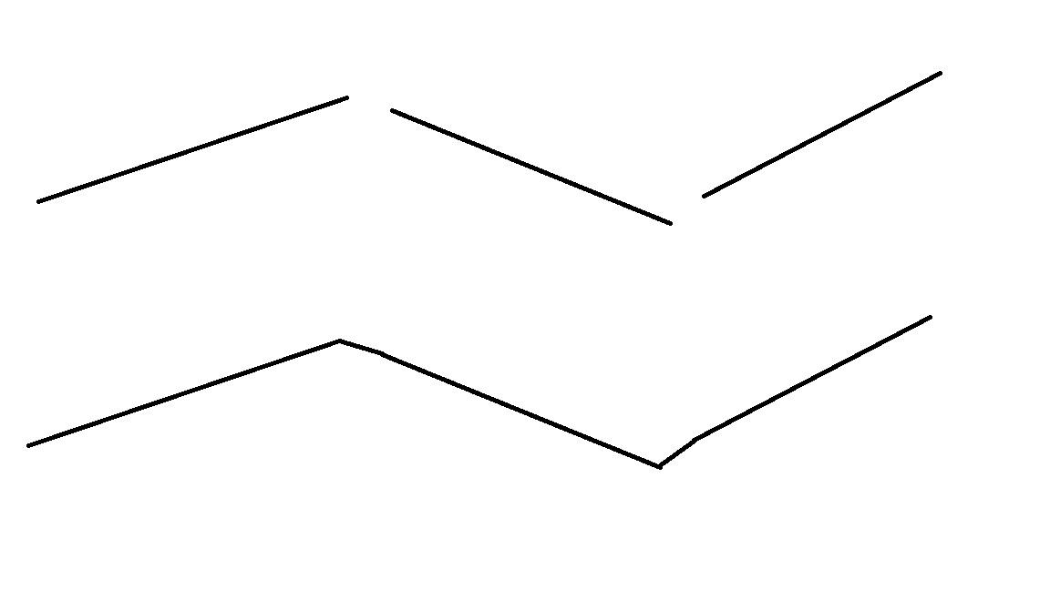
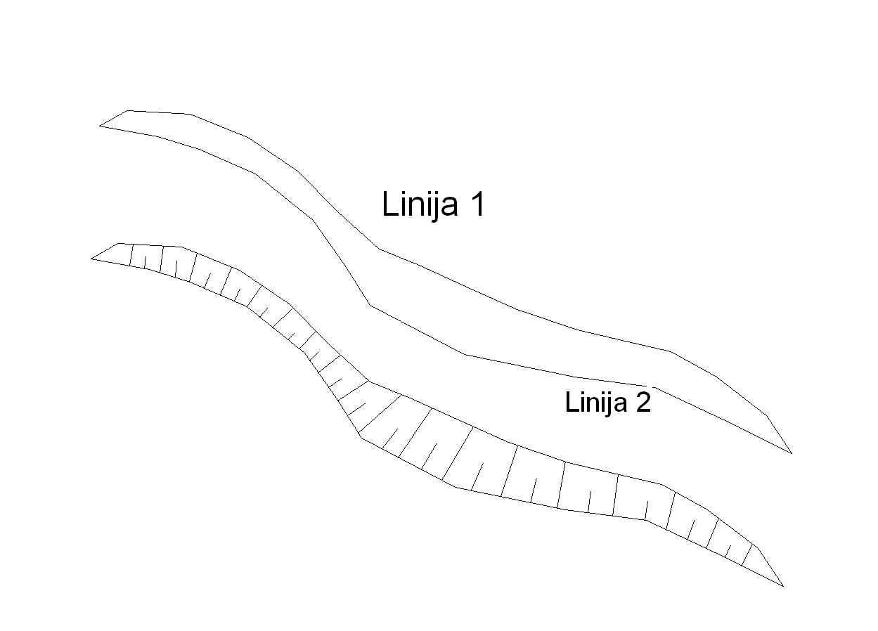
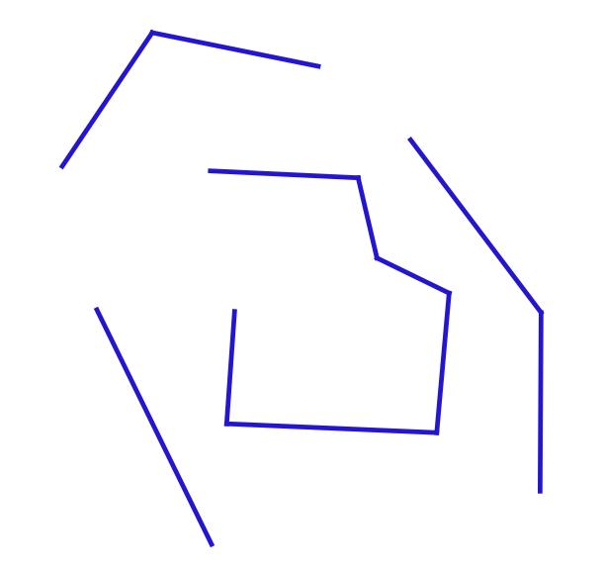
For example:
- Two roads that do not meet.
- Two hiking paths that never cross.
- Two CAD paths separated from each other.

No Intersection in CAD
# Source: AI Source: Provided by: [Data Path: Persons Table -> ID Column: 1, Name_En Column: Motasem Essam] -> From: [ChatGPT] on [7/25/2026]
CAD systems need to determine whether geometric objects intersect.
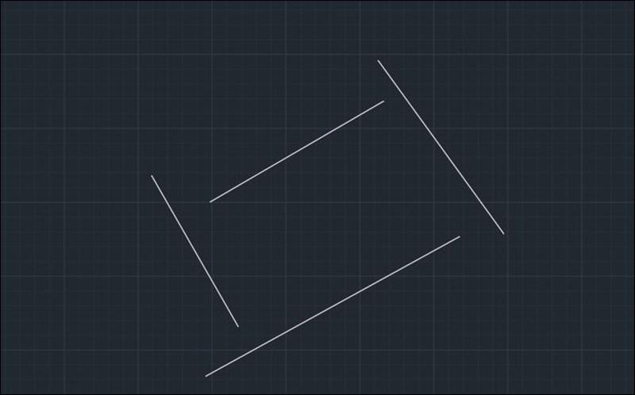
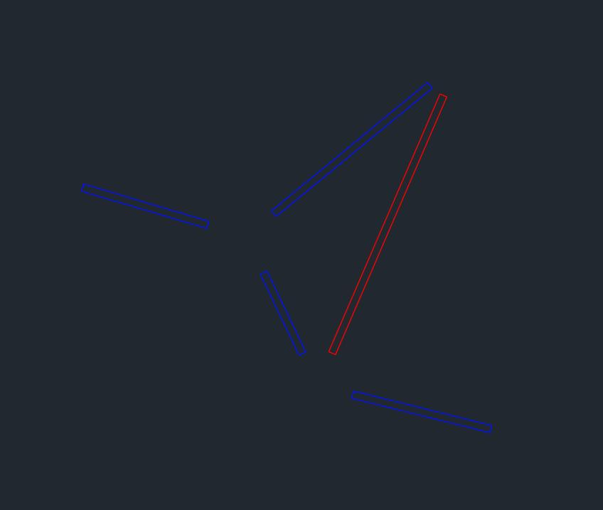
No-intersection detection can be used to:
- Check clearances.
- Detect gaps.
- Prevent unwanted connections.
- Analyze designs.
- Identify disconnected geometry.
- Perform collision testing.

No Intersection in GIS
# Source: AI Source: Provided by: [Data Path: Persons Table -> ID Column: 1, Name_En Column: Motasem Essam] -> From: [ChatGPT] on [7/25/2026]
GIS uses segment intersection testing to determine whether geographical features meet.
For example:
- Roads.
- Railway lines.
- Pipelines.
- Boundaries.
- Trails.
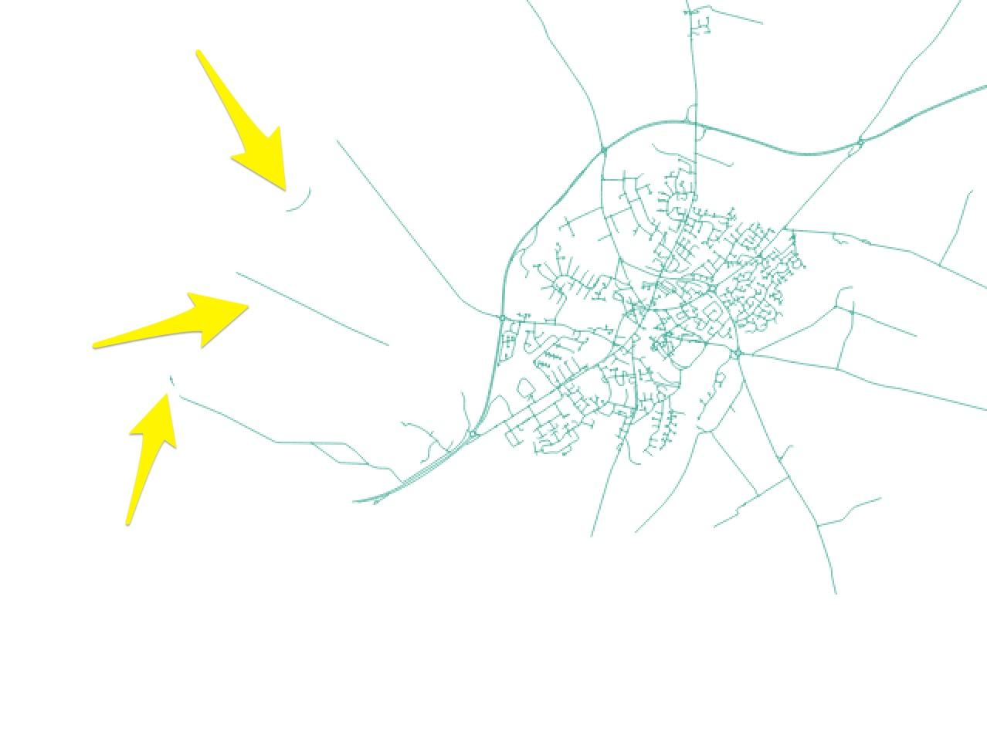
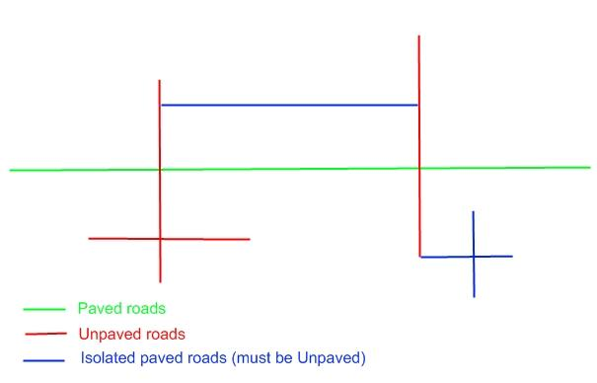
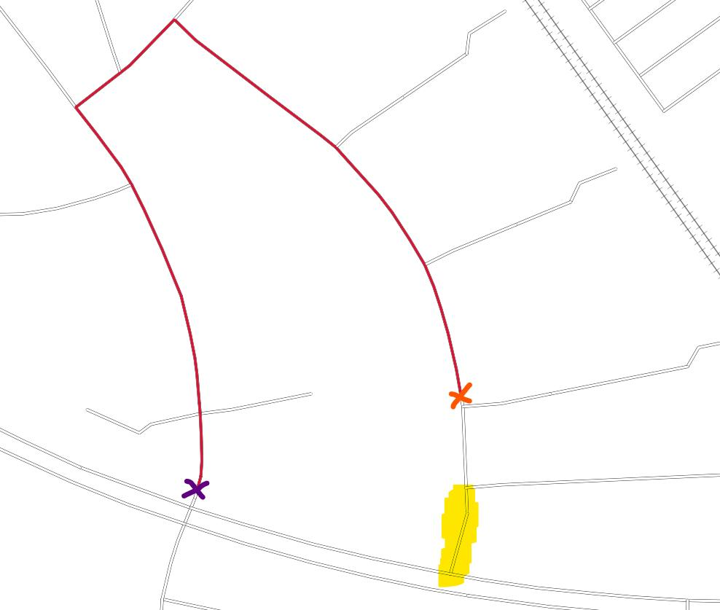
If two features do not meet:
$$\boxed{\text{No Segment Intersection}}$$

No Intersection in Computer Graphics
# Source: AI Source: Provided by: [Data Path: Persons Table -> ID Column: 1, Name_En Column: Motasem Essam] -> From: [ChatGPT] on [7/25/2026]
Computer graphics uses non-intersection testing for:
- Collision detection.
- Visibility calculations.
- Polygon clipping.
- Path planning.
- Shape processing.
- Vector graphics.
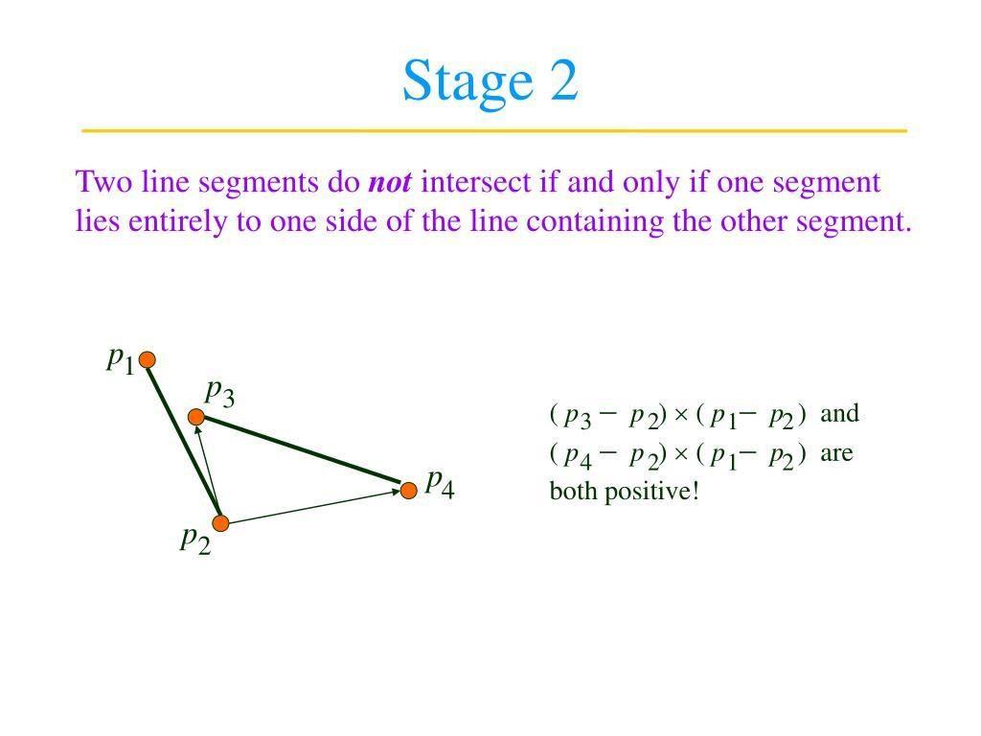
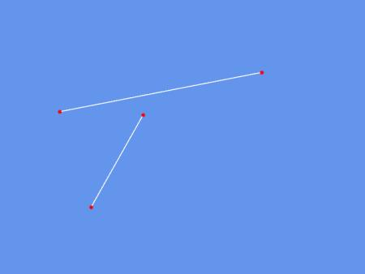
For example, if two moving objects' boundaries do not intersect, they may not have collided.

Real-World Examples
# Source: AI Source: Provided by: [Data Path: Persons Table -> ID Column: 1, Name_En Column: Motasem Essam] -> From: [ChatGPT] on [7/25/2026]
No segment intersection can represent:
- Two roads that do not meet.
- Two railway sections separated by distance.
- Two walls with a gap between them.
- Two paths that never cross.
- Two boundaries that are separated.
- Two structural members that do not connect.
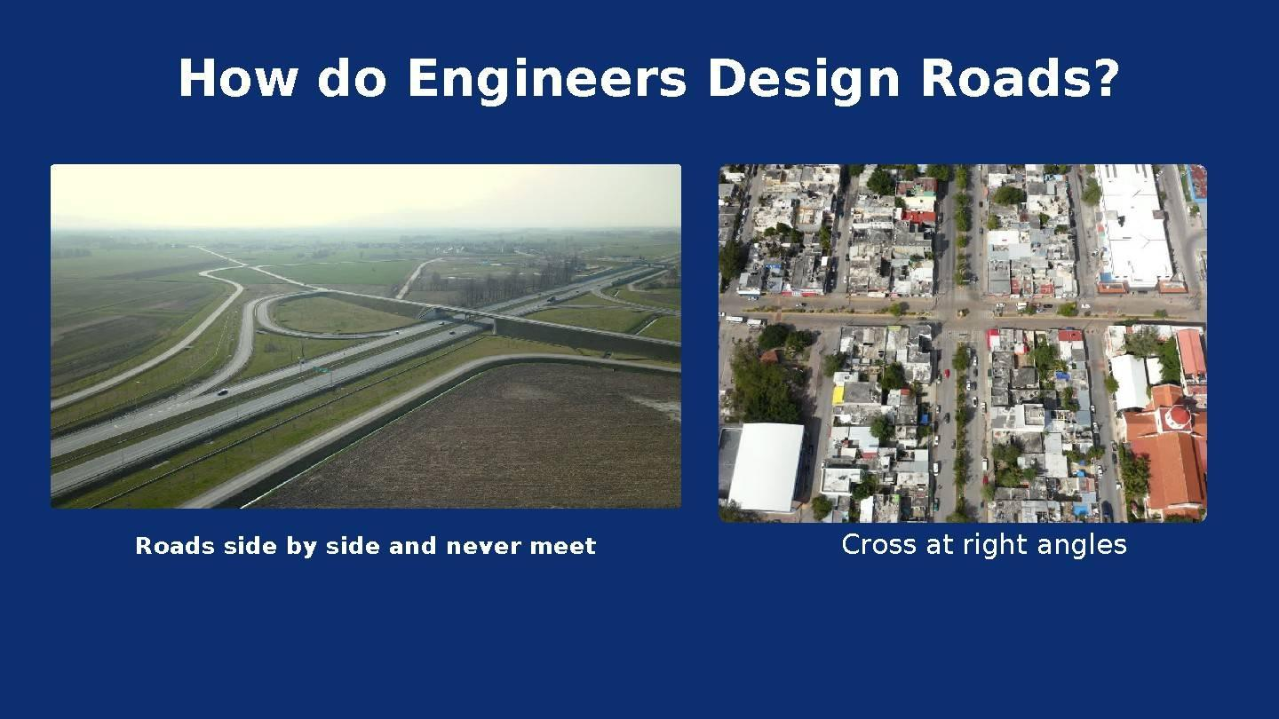


Applications
# Source: AI Source: Provided by: [Data Path: Persons Table -> ID Column: 1, Name_En Column: Motasem Essam] -> From: [ChatGPT] on [7/25/2026]
No Segment Intersection is important in:
- Plane Geometry
- Coordinate Geometry
- Computational Geometry
- Polygon Theory
- Polyline Geometry
- Architecture
- Civil Engineering
- Mechanical Engineering
- Surveying
- GIS
- CAD
- Computer Graphics
- Robotics
- Navigation
- Collision Detection

Advantages
# Source: AI Source: Provided by: [Data Path: Persons Table -> ID Column: 1, Name_En Column: Motasem Essam] -> From: [ChatGPT] on [7/25/2026]
Studying no intersection helps to:
- Determine whether geometric objects are separated.
- Detect gaps between segments.
- Check whether paths cross.
- Prevent unwanted collisions.
- Analyze polygon structures.
- Verify CAD designs.
- Analyze road and network layouts.
- Improve geometric algorithms.

Limitations
# Source: AI Source: Provided by: [Data Path: Persons Table -> ID Column: 1, Name_En Column: Motasem Essam] -> From: [ChatGPT] on [7/25/2026]
No Segment Intersection:
- Does not describe how far apart the segments are by itself.
- Requires checking the entire geometry of the segments.
- Can be more difficult to determine when segments are very close.
- Must be distinguished from endpoint touching.
- Must be distinguished from an intersection occurring outside the finite segments.

Comparison with Related Concepts
# Source: AI Source: Provided by: [Data Path: Persons Table -> ID Column: 1, Name_En Column: Motasem Essam] -> From: [ChatGPT] on [7/25/2026]
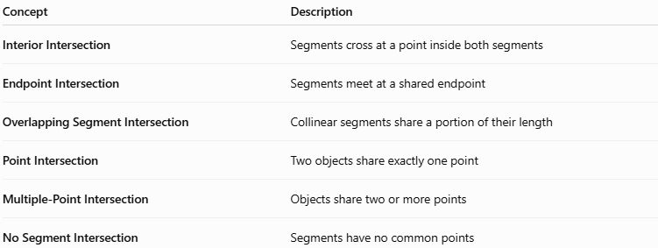
Concept | Description
Interior Intersection | Segments cross at a point inside both segments
Endpoint Intersection | Segments meet at a shared endpoint
Overlapping Segment Intersection | Collinear segments share a portion of their length
Point Intersection | Two objects share exactly one point
Multiple-Point Intersection | Objects share two or more points
No Segment Intersection | Segments have no common points

Complete Segment Intersection Classification
# Source: AI Source: Provided by: [Data Path: Persons Table -> ID Column: 1, Name_En Column: Motasem Essam] -> From: [ChatGPT] on [7/25/2026]
The main cases can be summarized as:
$$\boxed{\begin{aligned}\text{Interior Intersection}&→\text{One interior point} \\ \text{Endpoint Intersection}&→\text{Shared endpoint} \\ \text{Overlapping Intersection}→\text{Shared segment} \\ \text{No Intersection}→\text{No common points}\end{aligned}}$$
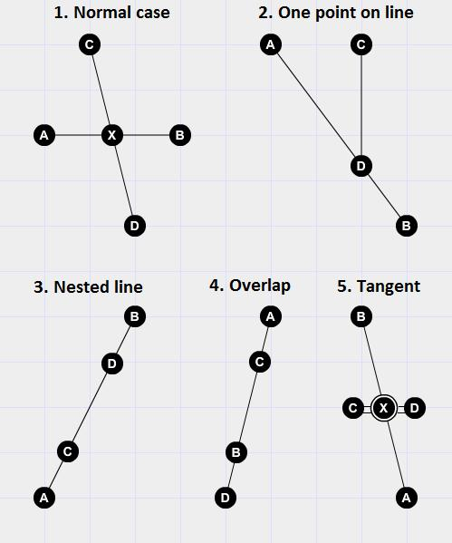

Key Points
# Source: AI Source: Provided by: [Data Path: Persons Table -> ID Column: 1, Name_En Column: Motasem Essam] -> From: [ChatGPT] on [7/25/2026]
- No Segment Intersection means two line segments have no common points.
- Its mathematical representation is:
$$\boxed{\overline{AB}∩\overline{CD}=∅}$$
- Segments can be:
  - Parallel and separate.
  - Collinear but separated.
  - Non-parallel and still completely separate.
- The infinite supporting lines may intersect even when the finite segments do not.
- No intersection is different from:
  - Interior intersection.
  - Endpoint intersection.
  - Overlapping intersection.
- It is important in geometry, coordinate geometry, CAD, GIS, engineering, computer graphics, robotics, and collision detection.

Conclusion
# Source: AI Source: Provided by: [Data Path: Persons Table -> ID Column: 1, Name_En Column: Motasem Essam] -> From: [ChatGPT] on [7/25/2026]
No Segment Intersection occurs when two line segments have no common point. The segments may be parallel, collinear and separated, or oriented in different directions while remaining completely apart. It is important to distinguish the finite segments from their infinite supporting lines, because the supporting lines may intersect even when the segments themselves do not. No Segment Intersection is a fundamental concept in plane geometry, coordinate geometry, computational geometry, CAD, GIS, engineering, computer graphics, robotics, and navigation, where determining whether objects are connected, separated, or collision-free is essential.

